# Inventory Models

* How much should be ordered each time
* When should the reordering occur (How Often?)

The objective is to minimize total variable cost over a specified time period

# Inventory Costs

* Ordering cost
  + salaries and expenses of processing an order
* Holding cost
  + percentage of the value of the item assessed for keeping an item in inventory
  + eg: finance costs, insurance, security costs, taxes, warehouse overhead
* Backorder cost
  + costs associated with being out of stock when an item is demanded e,g.lost goodwill or lost sales
* Purchase cost
  + the actual price of the items

# Economic Order Quantity (EOQ)

* Simplest models assume demand and the other parameters of the problem to be deterministic and constant (确定性和持续性), also it is most basic of the deterministic inventory models
* variable costs in this model are annual holding cost and annual ordering cost
* EOQ, the annual holding and ordering costs are equal

## Problem

Involves determining the optimal quantity to purchase when orders are placed

Small orders:

* low inventory levels & holding costs
* frequent orders & higher ordering costs

Large orders:

* higher inventory levels & holding costs
* infrequent orders & lower ordering costs

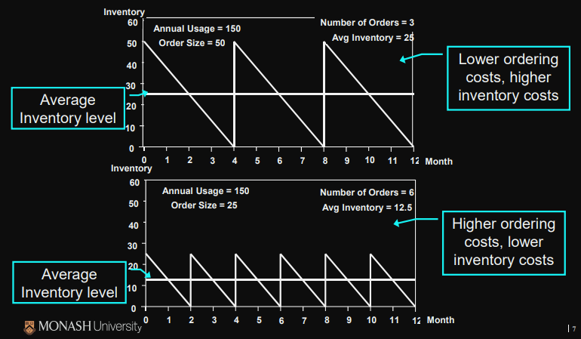

## Assumptions

* Demand is constant throughout the year
* Purchase cost per unit is constant
* Delivery time (lead time) is constant
* Planned shortages are not permitted
* when all of the assumptions of the economic order quantity (EOQ) do not hold, the model may still be used as a good guide to ordering.

## Relationships

the quantity of stock to be ordered which minimises the total (annual) cost of holding and purchasing stock when the demand for goods is constant

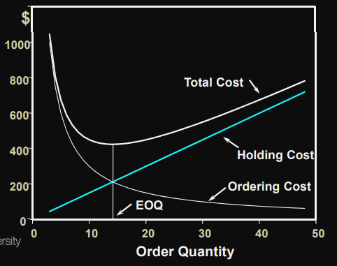

## Derivation

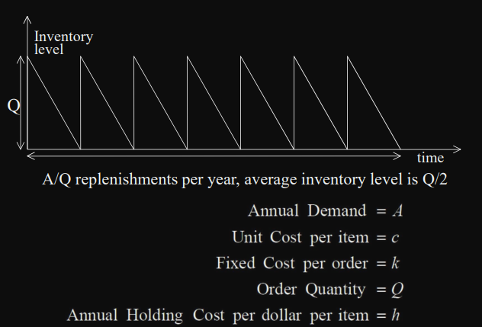 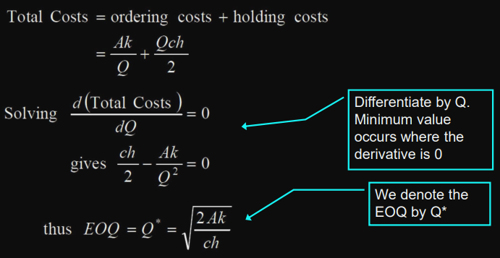

## Formulae

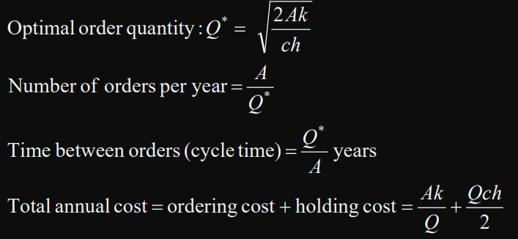

## Example 1

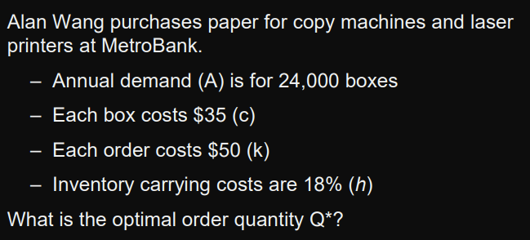 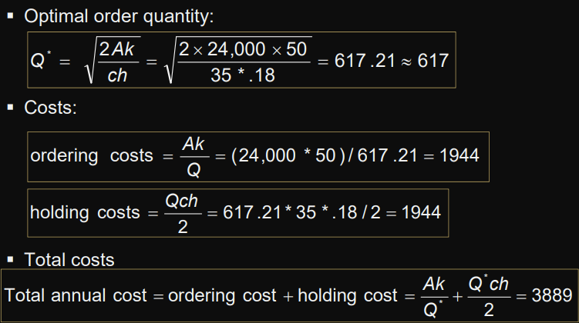

change the order quantity to 600? Very little change in Total Costs, but perhaps more convenient

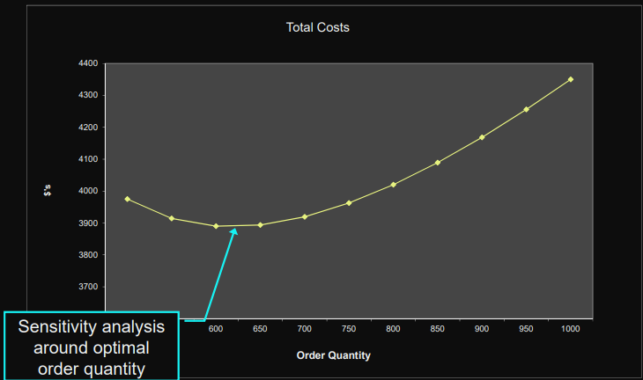

## Example 2

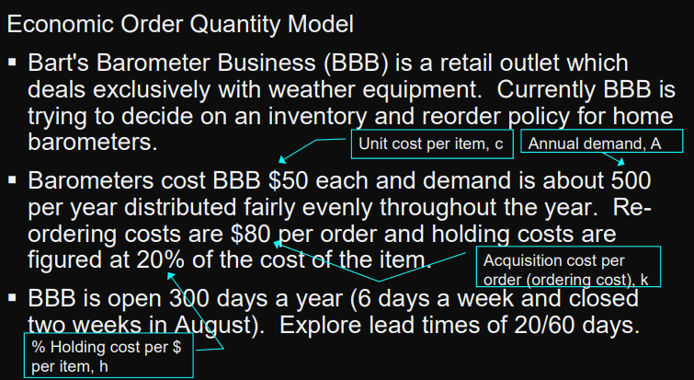 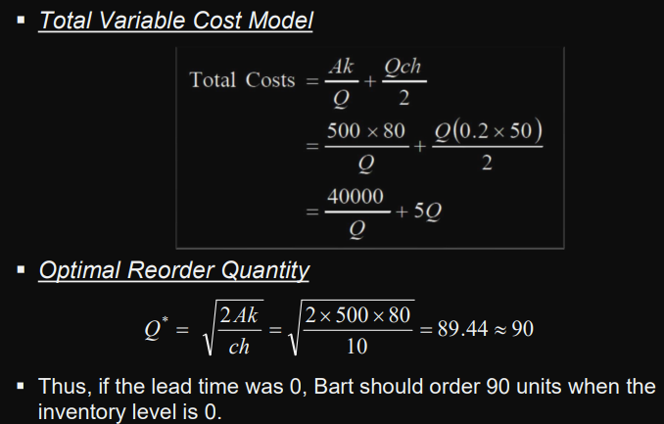 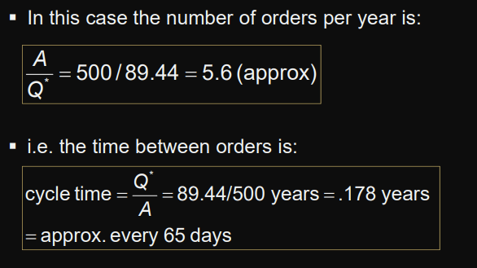 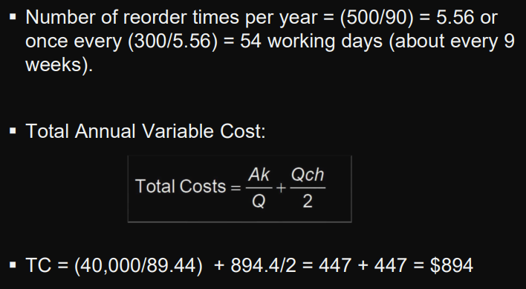 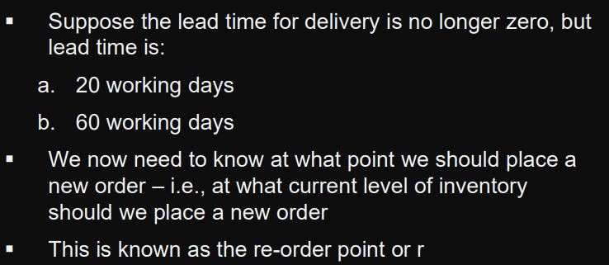 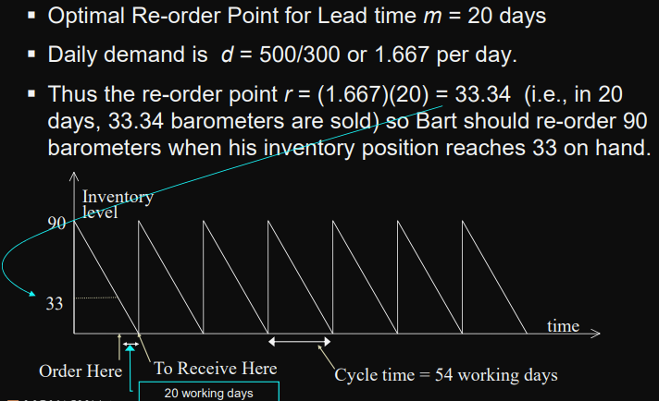 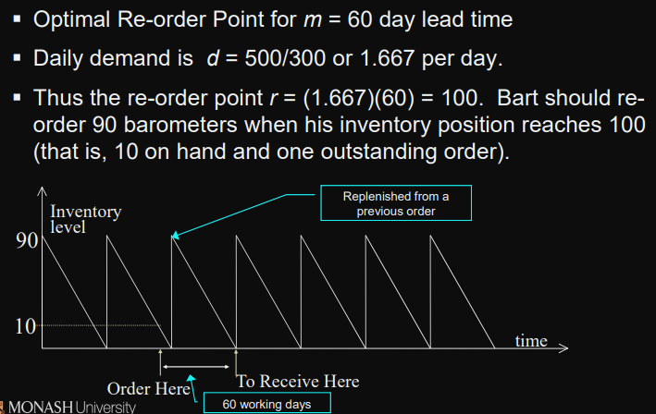 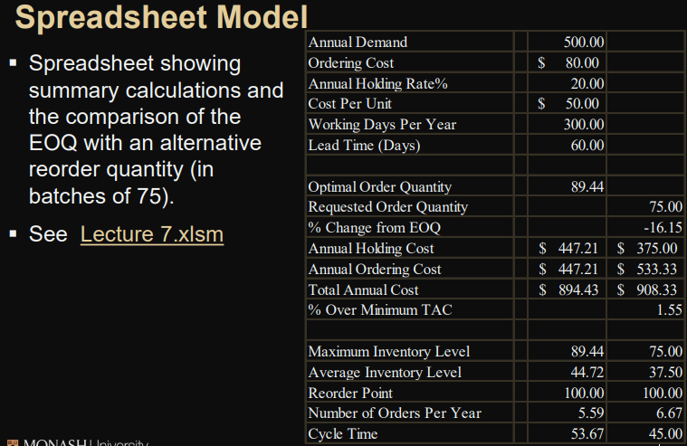

Summary

* A 16.15% negative deviation from the EOQ resulted in only a 1.55% increase in the Total Annual Cost.
* Annual Holding Cost and Annual Ordering Cost are no longer equal.
* The Re-order Point is not affected, in this model, by a change in the Order Quantity.

## EOQ Planned Shortages

* With the EOQ with planned shortages model, replenishment order does not arrive at or before the inventory position drops to zero
* Shortages occur until a predetermined back-order quantity is reached
* variable costs in this model are annual holding, backorder, and ordering.
* For the optimal order and back-order quantity combination, the sum of the annual holding and back-ordering costs equals the annual ordering cost

### Assumptions

* Demand occurs at a constant rate of A items per year
* Ordering cost: $k per order
* Holding cost: $ch per item in inventory per year
* Backorder penalty cost: $p per item back-ordered per year
* Purchase cost per unit is constant
* Set-up time (lead time) is constant

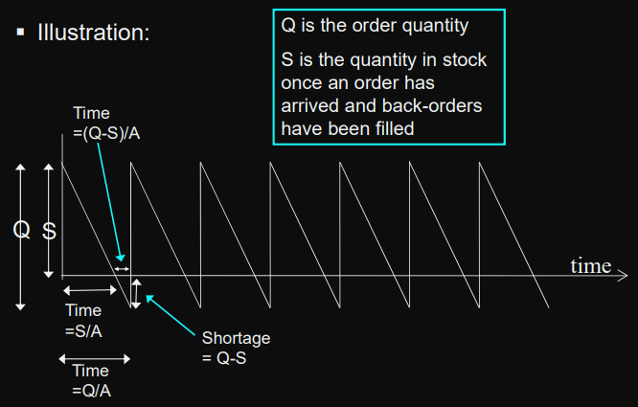

### Fomula

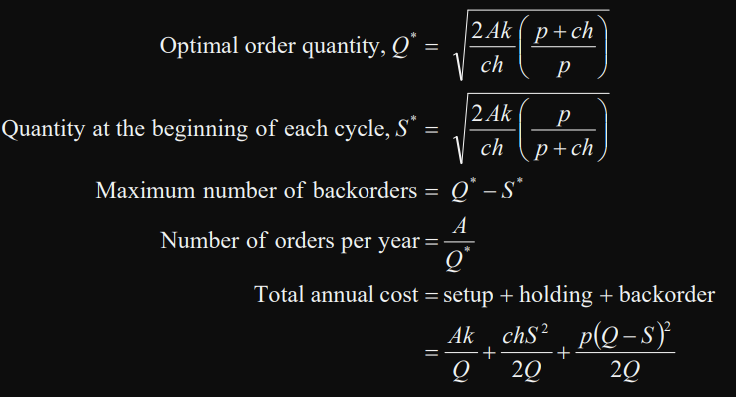

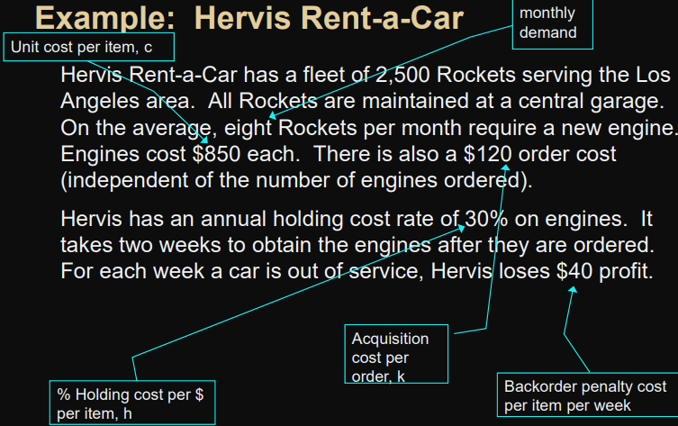 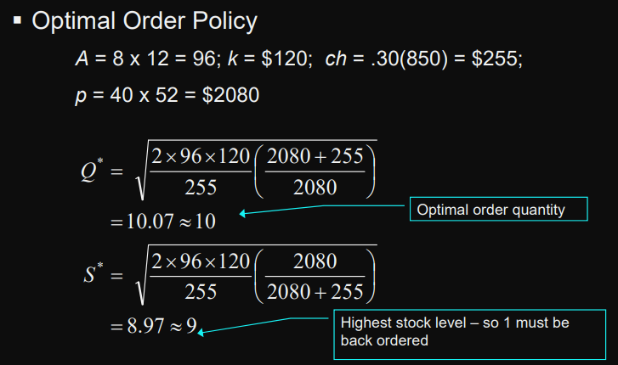 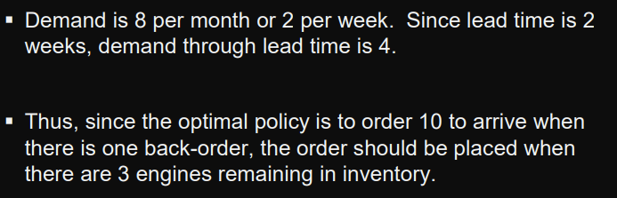 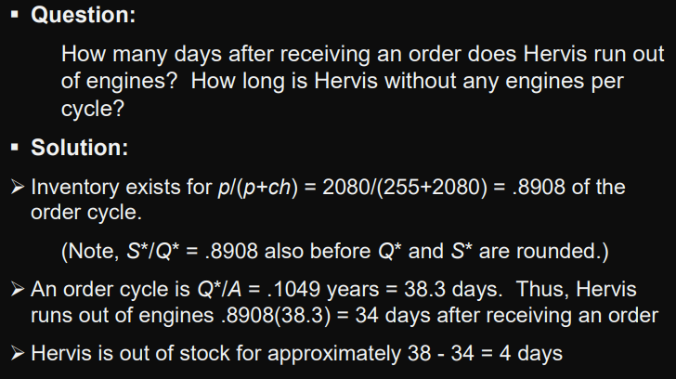

## EOQ with Quantity Discounts

* applicable where a supplier offers a lower purchase cost when an item is ordered in larger quantities
* model’s variable costs are annual holding, ordering and purchase costs
* the annual holding and ordering costs are not necessarily equal.

### Assumptions

* Demand occurs at a constant rate of A items per year
* Ordering Cost is $k per order.
* Holding Cost is h. This is equivalent to $ch per item in inventory per year as per previous models.
* Purchase Cost is
  + $c1 per item if the quantity ordered is between 0 and x1 ,
  + $c2 if the order quantity is between x1 and x2
* Delivery time (lead time) is constant.
* Planned shortages are not permitted

### Formulae

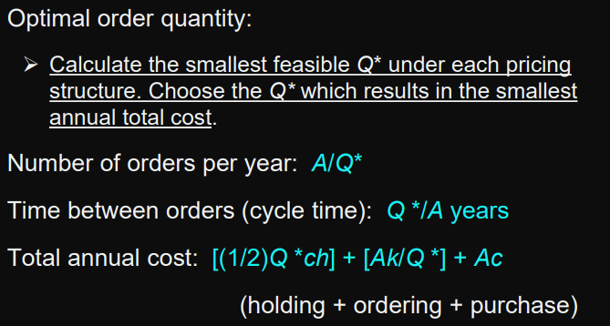

### Example

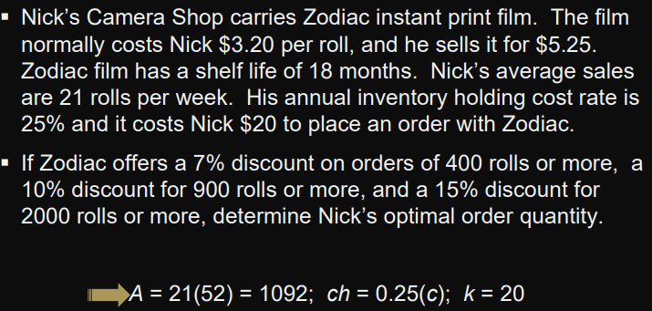 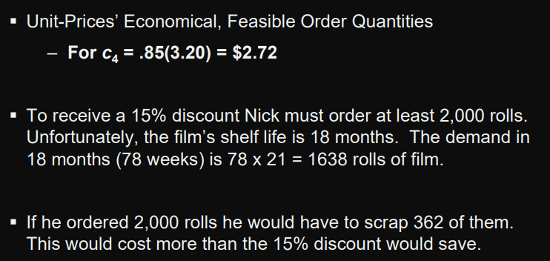 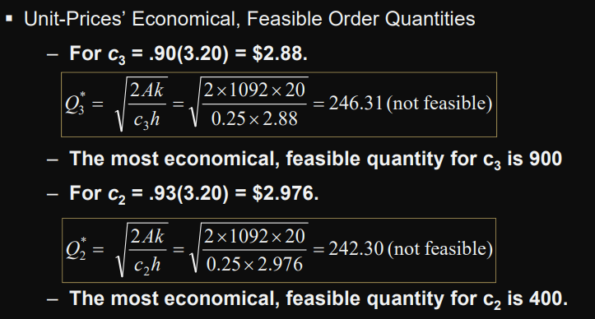 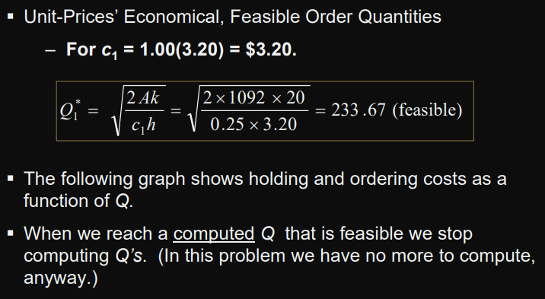 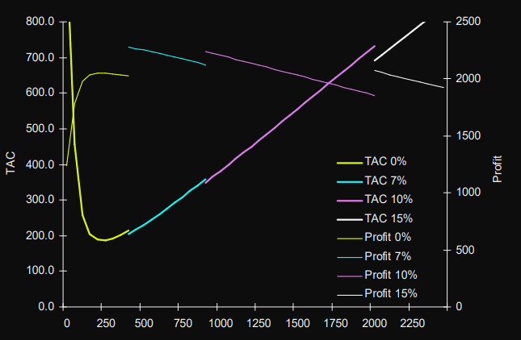 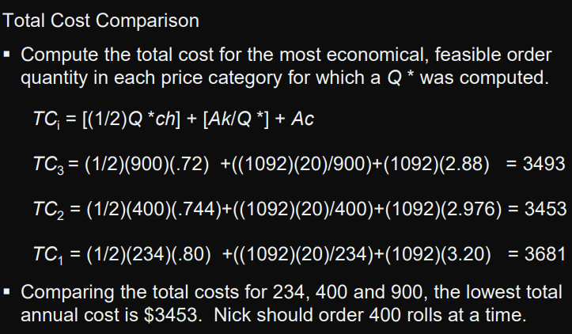

## Economic Production Lot Size

* economic production lot size model is a variation of the basic EOQ model
* replenishment order is not received in one lump sum as it is in the basic EOQ model
* Inventory is replenished gradually as the order is produced
* model’s variable costs are annual holding cost and annual set-up cost
* For the optimal lot size, annual holding and set-up costs are equal

### Assumptions

* Demand occurs at a constant rate of A items per year
* Production rate is B items per year (and B > A)
* Set-up cost: $k per run.
* Holding cost: $ch per item in inventory per year
* Manufacturing cost per unit is constant
* Set-up time (lead time) is constant.
* Planned shortages are not permitted

### Formulae

